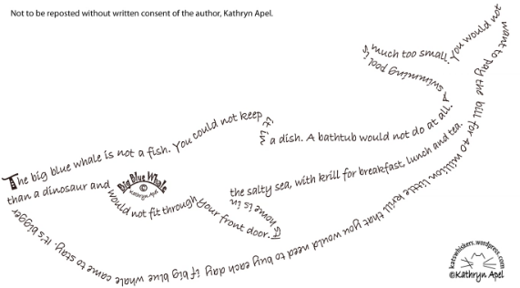
Shape Poem Rubric
Name: ___________________________________________
 | Above Standard  (4 points) | Meets Standard  (3 points) | Approaching Standard  (2 points) | Below Standard  (1 point)
Construction | The arrangement of letters and words clearly and exceptionally creates an image that offers meaning visually. | The arrangement of letters and words clearly creates an image that offers meaning visually. | The arrangement of letters and words attempts to create an image that offers meaning visually. | The arrangement of letters and words creates an image, but it does not seem as if the image offers much meaning visually.
Cohesion Through Writing | The poem clearly shows cohesive meaning through both the written poetry and the construction of the words and phrases. | The poem shows cohesive meaning through both the written poetry and the construction of the words and phrases. | The poem shows some cohesive meaning through both the written poetry and the construction of the words and phrases. | The poem does not show cohesive meaning through both the written poetry and the construction of the words and phrases.
Grammar/spelling | No grammar errors found. Finished product was completely edited for correct grammar and spelling. | 1-2 grammatical or spelling errors were found throughout the poem. | 3-4 grammatical or spelling errors were found throughout the poem. | More than 4 grammatical or spelling errors were present in the poem.
Word Choice | Words are appropriate, vivid with description. | The author used a lot of lively language (vivid verbs, adjectives, adverbs, etc.); original | The author included some lively language in their poem; weak descriptions | The poem uses dull, lifeless words that convey little meaning
Neatness | Overall appearance is excellent, the shape relating to the poem is well planned | Poem is presentable. The shape is present and planned | Poem is somewhat sloppy, the shape is somewhat related, there is some evidence of planning | Poem is sloppy, unreadable, not much thought put into it. The shape does not relate to the poem or there is no shape.

Total: ___/20 = ____%
Comments: ____________________________________________________________________
______________________________________________________________________________
______________________________________________________________________________
______________________________________________________________________________
______________________________________________________________________________
______________________________________________________________________________
______________________________________________________________________________
______________________________________________________________________________
______________________________________________________________________________
______________________________________________________________________________
______________________________________________________________________________
______________________________________________________________________________
______________________________________________________________________________

