Chapter 8: The Métis
Name:________________________

Chapter Inquiry – In what ways did the Métis have an impact on the development of Western Canada?
TERM | DEFINITION
Assimilation
Bill of Rights
Country Born Metis
Demographics
Identity
Manitoba Act
Metis Provisional Government
Migration
Pemmican Proclamation
York Boat
Emerging Identities - Your identity is the set of _________________________ and __________ that you use to express who you are. Some groups may dress differently, follow different ______________ , speak different ________________ , and hold different ____________________ or points of view. These are all ways of an identity.
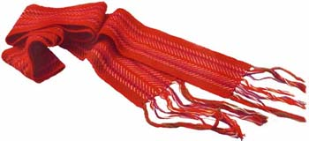
Citizenship and Identity – One result of contact between the First Nations and Europeans was the emergence of the __________ . By the mid-1800s most of the Métis lived in Red River, Manitoba.
An Emerging Identity In The West
The children of First Nations ___________ and European _______ were called ___________. They lived all over North America but the largest community of Métis lived in Red River, Manitoba, which is now called ______________ .
When we examine the characteristics of the people of a particular place we are referring to the demographics of the place. They include information such as:
- the ___________ of people who live there, or
- the ratio of _______ to ___________ .
- How many Francophone Métis lived in the Red River region by 1840? _________
- What religion did most of them practice? _______________
- How many non-Métis people lived in the area? ___________
ABOUT 1000 OTHER PEOPLE LIVED NEAR RED RIVER:
- Country Born Métis were the children of First Nation women and ____________ traders from the ____________ _____ ______________. These Métis were usually _______________ (non-Catholics) like their fathers and also held some First Nations beliefs.
- _______ and ________________ First Nations.
- Roman Catholic ___________________ - who built churches and schools which became the centres of _________________ Métis communities.
- The ______________ who lived in St. Boniface.
- _____________ employees of the Hudson’s Bay Company.

SHARED CULTURE OF THE RED RIVER METIS:
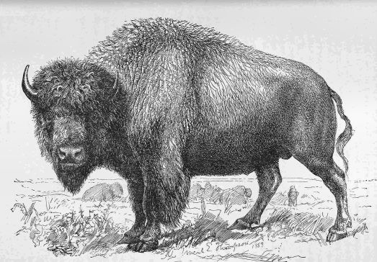
The Red River Métis shared a unique culture that shaped their identity. They developed their own language, artistic style, poetry, music, dance (_____), and economy. The Metis learned several languages, including their own language called ____________.
Shared Economy – What does the word “economy” mean? _____________________________________
___________________________________________
___________________________________________ How did the Métis make a living? _________________
___________________________________________________________________
Jobs in the ____________________________________________________________
____________________________________________________________________
The Metis in the Fur Trade: How were the Métis important to the success of the fur trade? _______________________________________________________________
_____________________________________________________________________
_____________________________________________________________________ The Buffalo Hunt: What role did Métis play in the Buffalo Hunt?
- Expert _____________
- Hunt was a focus on their _____ ___ ______.
- A ____________ would _______________ the hunt.
- Woman cut up the meat, dry it, then pound it into shreds. Mixed with fat & berries is called - _______________.
- Would sell the Pemmican as it was a staple food for hunters in the West.
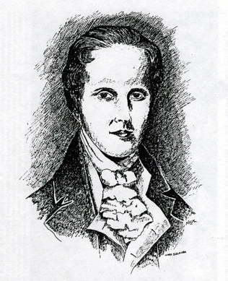
Conflict At The Red River
In the 1800s a Scottish nobleman named Lord __________ bought a huge piece of ________ from the Hudson’s Bay Company. He brought dozens of ______________ to the land from the Highlands of ______________. He hoped that they would be able to turn the land at _____ ________ into a great ______________ colony. However, the land was _______ empty, and a large Métis community was already established and living there.

Métis Reaction to the Colonists – The Métis had no _________ papers that said they _________ the land that they had been farming for more than _____ years. They were worried that these _____________ would push them off their farms.
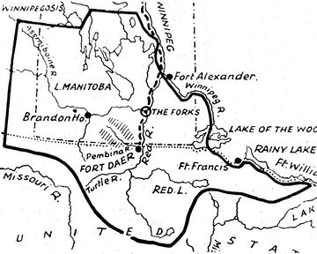
The North West Company employees allied with the __________ and _________ the colony. They were competing with the Hudson’s Bay Company for control of the ______ __________. They thought the HBC sent Selkirk and the colonists to disrupt their trade.

Conflict over Resources – The governor was _______________ that his colonists would _________ if all the food was exported out of the region, so in 1814, he __________ the Métis from exporting any __________, _______, or ________________ from the region.

What did they call this order? ____________________________________________.

The ____’______________ and the Red River Métis were outraged by this order because the buffalo meat trade was important to the Metis _______________ and economy. So they tried to force the Selkirk _________ from their area by stealing their farm equipment, ____________ and frightening the settlers by shooting off their guns. As a result of these actions and a series of natural ________________, many of the colonists left.
Battle of Seven Oaks - The battle was fought between the ______________ Scottish Colonists and the ___________. The two sides faced each other near a grove of ____ trees beside the Red River. A fierce fight broke out, one Metis and _____ Colonists were killed. This was the first time that the Métis stood up as a ____________ group against the Canadian ________________. The event marked the beginning of the Métis Nation.
Migration Further West – The Hudson’s Bay Company (owned by the ___________) took _______ the North West Company and with the purchase they also took over all their lands. The ___________ began to ______ out and the Métis hunters had to travel ______ from the Red River colony to find a herd. To be closer to the buffalo the Métis ________________ and settlements were set up in the provinces of _______________________ and ________________.
Red River Resistance, 1869
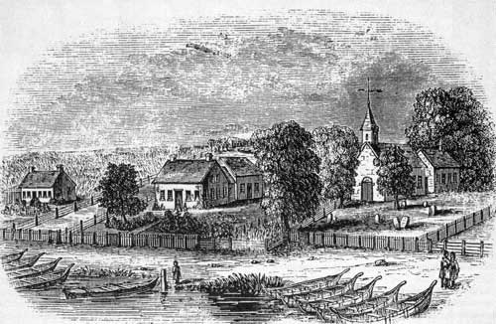
Red River Métis believed that _____________ _______ belonged to them.
The government of ____________ thought it would make a good place to send European colonists.The government sent scientific teams to the _________ and they reported that the region was well suited to ______________, and had many ______________ resources. Outsiders started to take notice of the west. At the same time there was a shortage of ______________ in Ontario. People began looking ouside __________ Canada for new ares to colonize, and Rupert’s Land looked like just the place.
Rupert’s Land Joins Canada - Some ____________ newcomers began to arrive in Red River area and the Canadian government realized that if they didn’t ___________ claim Rupert’s Land, the United States would. In _______ they purchased the territory from the Hudson’s Bay Company for $ _____ million dollars.
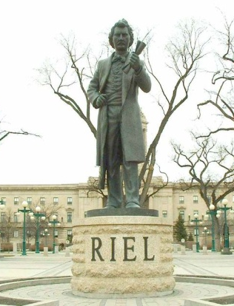
Fears of Assimilation - The First Nations and Metis living in Rupert’s Land were not consulted about the sale of the land and were uncertain about their _____________. They were worried about ________________ which is when one culture is _______________ into another _____________.
Red River Resistance, 1869 – Canada was ready to take ___________ of Rupert’s Land on December 1st, _______.
- The Federal Government sent surveyors to Red River without telling the First Nations and Métis.
- Louis Riel was a Metis, who could speak __________, ___________, and ________. He stopped the surveyors and told them to leave Red River immediately. This gave them time to decide how to ___________ their land
- Riel became the _____________ of the Métis Provisional Government and helped draw up a _______ of ___________ to be presented to the Government of ____________. This bill was meant to ____________ the interests of the different groups of people living in the area.

French and English Canada Take Sides – Not everyone in Red River supported the Métis _____________. The ____________ -speaking colonists were furious with the _________________ (French speaking) Metis. The Métis _________ an Englishman named ___________ __________ when he threatened to _______ Riel. He was found guilty and was executed in front of a ___________ squad. Depending on your perspective, your reaction to this event was very different.
The Anglophone Perspective: Scott was an ____________-speaking Protestant. His death made the ____________ population in Ontario want revenge.
The Francophone Perspective: The Canadiens in __________ reacted differently. They saw the Métis as ________________ of the Francophone Catholic way of life.
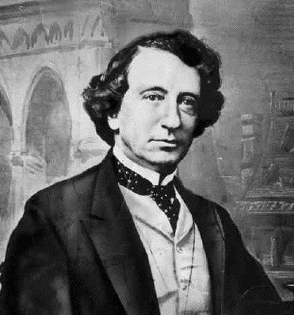
The Creation of Manitoba
Prime Minister John A ________________ wanted to find a solution to the crisis, in July ______, the government passed the ______________ Act to try to please both sides. This act would create the ______ province in Canada.
Some of the most important terms of the Manitoba act:
- It gave Manitoba its own ________________ government
- Both __________ and ____________ would be spoken in the government and court.
- The province could send _______ members to the House of Commons in Ottawa and _____ members to the ___________.
- There would be a ____________ for Protestants and ______________ that would be _____________ funded.
- Land would be set aside for the __________ to use.
- Natural ___________ would be under the control of the ___________ government.
Soldiers on the March – The Prime Minister sent ______ soldiers to Red River to keep the peace and defend the area in case the United States tried to _________ it. Many of the soldiers thought they were there to __________ the Métis and capture Louis ______ . Knowing his life was in danger, he ______________ to the United States. Some of the soldiers took out their anger on the ___________ by killing, jailing and beating them. It was a bad bginning for the new province of _______________.
Second Metis Uprising, 1885 – The _____________ of the Province of Manitoba didn’t solve all the problems for the Métis and First Nations people.
Why did problems persist?
- ________________________________________________________________
________________________________________________________________
- ________________________________________________________________
________________________________________________________________
- ________________________________________________________________
________________________________________________________________
- ________________________________________________________________
________________________________________________________________

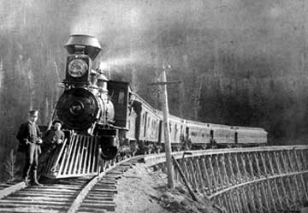
Metis and First Nations Grievances – By the 1880s, the Metis faced several challenges to their way of life, such as _________________ and _____________. This was a result of the reduced _____________ population.
Why did the government ignore the Métis concerns?
- Because they were more focused on what they thought was a more important issue which was the building of the ______________ Pacific _____________ .
- It was a priority because they wanted more colonists to move onto the ___________ and develop the ________.
RIEL RETURNS: In the summer of 1844, a group of Metis led by Garbriel Dumont went & invited Riel back to ____________ from the United States. The Métis were __________ and impatient that nothing was being done about their _____________ . They wanted Riel to be their _________.
Riel and the Métis set up their own government and demanded that:
- ______________________________________________________________
- ______________________________________________________________
- ______________________________________________________________

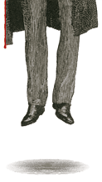
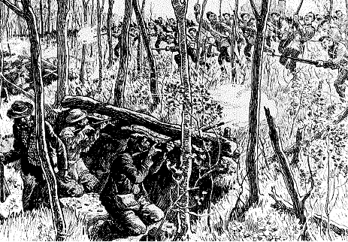
When nothing happened, Riel suggested they take up _______. Gabriel Dumont was a strong supporter of Riel, so they decided to join in the uprising. ____________was the military general for the Métis forces. The Northwest Resistance of 1885 was violent, but brief. The federal government rushed _____________ of soldiers west aboard the newly built _____________. After ____ days of fighting, the resistance was over, and the Métis ___________________.
The Fate of Louis Riel - Following the Resistance, Louis Riel was accused of ___________ (or the betrayal of one’s _____________.) A jury found him __________ and Riel was sentenced to a ________. Prime Minister John A. Macdonald delayed the execution _________ because of a federal _____________. If he sided with ____________ (the English), rather than Quebec he would likely ______ the election.
Explain the dilemma that Prime Minister Sir John A. Macdonald found himself having to deal with by completing the following chart with information found in your textbook.
Macdonald’s Election Dilemma
The French (Quebec) | The English (Ontario)

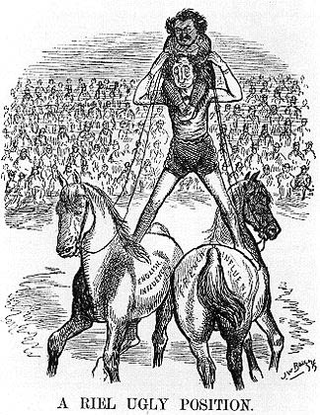
Analyze the cartoon on the left by using the Skill Check feature on page 218 of your text book. Explain the cartoon, who/what is being depicted in it? (8 Marks)

On ________________ 16th, _______, Riel was taken from his jail cell in ___________ and hanged. Riel’s execution confirmed the suspicions of the _______________ that their ___________________ “partnership” with English Canada was unequal.
Aboriginal people in the West were punished for their ‘role’ in the resistance. Only a few had joined the resistance, but whole ocmmunties were punished serverly by having their government food rations stopped (even though there was limited buffalo left) and they were told to stay on their reserves unless they had permission from a government agent to travel.These restircitons opened up land to more European farmers nad allowed the government ot continue expanding the CPR without fear of another resistance.
The Métis wanted rights __________ to the people in other ________________, but the government ______________ their requests.
Their struggle to be recognized as a ____________ people would remain ______________ for many years to come.

