Chapter 2: The French in North America Name: Key

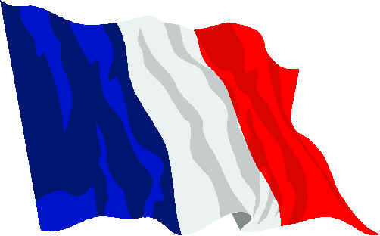
Chapter Inquiry: What kind of society did the French Colonists create in their North American colonies?
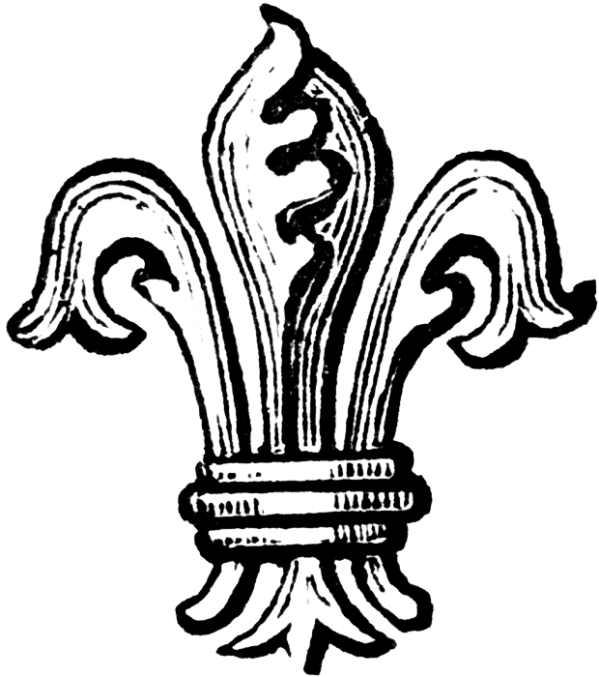
Vocabulary: Use the glossary or text to define the following.
Acadians A Francophone citizen of Acadia (Nova Scotia)
Citizen A member of a society or country
Bishop A high-ranking official (cleric) in the Roman Catholic church in New France.
Colony A territory that is controlled by another country.
Coureurs de bois A Canadien trader (“runner of the woods” in English) who paddled on long journeys into the North American wilderness to trade for furs with the First Nations People.
Empire A network of colonies that is controlled by a single country.
Governor A powerful official in New France, he was the king’s personal representative in the colony. He was the most powerful member of the Sovereign Council
Habitant A Francophone (French) farmer in New France.
Imperialism When a country extends its control over other countries, often by using economic or military means.
Intendant In New France, this was the second most important position of the Sovereign Council, he was in charge of the day-to-day affairs of the colony.
Jesuits An order of Roman Catholic missionaries who came to North America to convert the First Nations People to the Roman Catholic religion.
Francophone A person for whom French is their first language learned and is still in use. A person of French language and culture.

Norse* People who came from Scandinavia (Vikings).
Petroglyphs * Drawings created by the First Nations People on rocks that recorded important events and information.
Seigneurial System A social system that was based on Nobles (seigneurs) who rented land out to farmers (Habitants) who then paid rent with a share of their crops. In return the Nobles had to build a grain mill and church.
Silk Road * A dangerous overland route from Europe to Asia. It was used by traders to transport spices, tea, porcelain and precious gems back to Europe.
Sovereign Council The government set up by King Lois in New France: It consisted of three key officials - a Governor, Intendant and Bishop.
Trade Monopoly* In New France, when only certain merchants would be allowed to trade their furs and in return would be expected to pay for building the new colony.
Chapter Notes
- How did New France get started? Fill in the flow chart using page 31 as your guide. Draw the arrows as well.
The colony shipped resources to the home country such as Fish , Furs , Lumber and Metal Ores .

Home Country
Colony
IMPERIALISM
The home country shipped settlers and soldiers to the colony. It controlled the economy and government of the colony.

- Why did the Europeans want to find a New Silk Road on water from Asia to Europe? They were often robbed by bandits along the route of their goods or they were charged a fee to pass. The Europeans wanted a shorter safer route.
- What kinds of goods where the Europeans looking for in Asia?
1. Spices 2. Tea 3. Silk 4. Porcelain 5. Gems
- List the 4 reasons that the imperial countries of Europe wanted to expand their Empires Across the Ocean and briefly explain each one.

1. ECONOMICS - Europeans set up colonies to claim the natural resources like furs, fish and timber for themselves.
2. COMPETITION - The countries of Europe were often at war with each other over things like land and resources. More colonies meant more power.
3. RELIGION - Most Europeans were Roman Catholic and they wanted to convert as many non-catholics as possible to their faith.
4. CURIOSITY – They were curious what was beyond the horizon of the ocean, advances in navigation equipment & ship design, allowed them to go further.
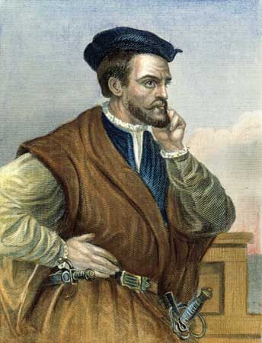
France Takes an Interest in North America - Jacques Cartier
- What year did Cartier set out to find a passage from North America to Asia? 1534 He had two ships when he sailed to the New World.
- Where did Cartier land after 20 days at sea? He landed off the coast of Newfoundland.
- Who were the first group Cartier met (they were paddling in their canoes)? A group of Mi’kmaq
- Why did Cartier sail farther up the St. Lawrence? He wanted to fish and establish a colony for the winter. Also to explore for more furs.

- Why did Cartier suffer and some of his crew die when they tried to spend the winter near Stadacona? Because they did not have enough fresh vegetables and they became ill from lack of vitamin C. This caused them to get scurvy.
- What causes scurvy and what did they do to cure the disease? A lack of vitamin C causes it. The First Nations People made them drink a tea out of White Cedar bark.
- In 1542, where did Cartier set up a colony? Along the St. Lawrence River at Quebec.
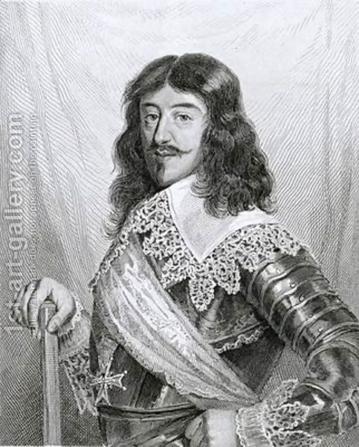
- Read the last paragraph on page 38 of your textbook. What is the most important contribution that Cartier succeeded in? Cartier gathered a wealth of information about things in New France.
France Expands Its Empire - King Louis XIII
a) What were the two reasons that King Louis wanted to build a colony in North America?
1. The abundant supply of furs and fish
2. He wanted to be the most powerful leader in Europe.
b) Why did King Louis set up trade monopolies?
This way someone else would pay for the expensive colonies – traders would get the monopoly in return.
c) Who were these first French pioneers? The Acadians were the first French pioneers.
Samuel de Champlain and Pierre de Monts
a) What two jobs did Samuel de Champlain do?
1. Map-maker 2. Explorer
b) In 1605, where did de Monts establish a settlement? Port Royal on the Bay of Fundy
c) What does the word Acadia mean? Acadia means “An Earthly Paradise”
d) What jobs did the Acadians do to survive in their new land?
1. Farming 2. Fishing 3. Hunting
e) Later on, de Monts and Champlain started another new settlement that came from the Algonquin word meaning “ the place where the river narrows ”. What do we call that site today? Quebec City .
f) Read the biography of Samuel de Champlain on page 41 of your text. Give a good reason why you think Champlain is called the founder of New France. He lived in Quebec for 27 years. He persuaded the King to send more colonists. He developed and established the fur trade in New France until it began to do well on its own.
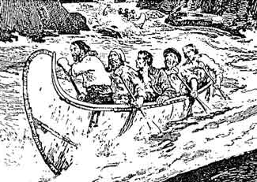
Coureurs de Bois
a) What does the term coureurs de bois mean in English? It means “runners of the woods” These men lived for long periods of time with the First Nations People and learned many skills from them.
b) How do you know that these adventurers were very intelligent?
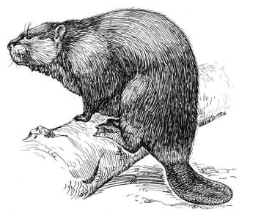
They learned to speak the languages of the First Nations People and how to build birch bark canoes and survive in the woods.
c) Give 3 reasons why the young French men were lured into the fur trade.
1. A promise of adventure
2. Freedom to explore
3. A way to make money
d) In what ways did these men help with the exploration of the new land? They acted as guides and interpreters for the French traders.
Who was Etienne Brule? A young French colonist and one of the first Coureurs de bois. He went and lived with the Wendat. He learned of their way of life, speak their language and practiced their customs. He travelled with the Wendat hunters.

Radisson and Groseilliers
- These two coureurs de bois were the first men to travel to the far end of Lake Superior. Along the way they claimed land for France. In 1670 . They travelled to Hudson Bay because they were looking for fur bearing animals.
- The biggest accomplishment Radisson and Groseilliers had was to start a fur trading business. What was the name of this business? The Hudson’s Bay Company
- When people from France explored new land, what was their goal? To claim the land and resources for the French home country.
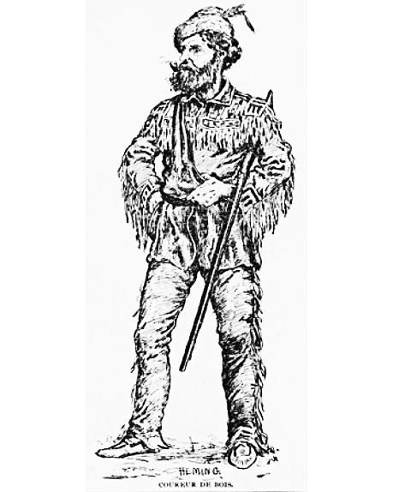
- What did the First Nations people believe about the land and its resources? They believed the land belonged, and should be shared with everyone.
- Why did the population of New France grow so slowly? Because is was difficult to convince people to move there because climate was much more harsh than France.
Economy and Government in New France
a) What 2 products made France richer and richer?
1. Furs 2. Fish
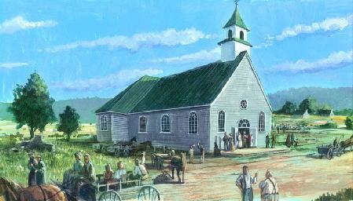
b) Why was King Louis XIV of France known as the Sun King? Refer to figure 2.14. Because he was all-powerful like the sun.
c) Since people did not want to settle in New France, King Louis XIV set up a Sovereign Council to govern the colony. Name the 3 officials and give a brief description of their responsibilities.
1. Governor The most powerful member of the Sovereign Council, he was the King’s personal representative in charge of the defence of the colony.
2. Intendant The second most important member of the Council, he was in charge of the day-to-day affairs like roads, tax collection etc.
3. Bishop The third member of the Sovereign Council, he was the head of the Roman Catholic Church in New France.
The Catholic Church in New France
What was the main religion of France and New France? Roman Catholic
What three religious groups of people came to New France to help build the colony.
1. Priests 2. Nuns 3. Missionaries
What were some of the jobs of the priests, nun and missionaries?
1. held religious services 2. taught school 3. looked after the sick and poor
What was the most important goal of the Church? To spread the Roman Catholic Faith
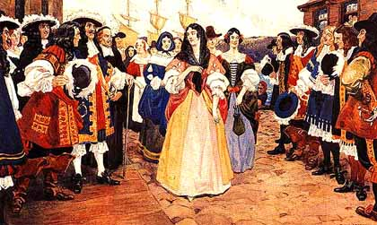
e) How did the Church get money to do its work? By taxing the colonists This is called a Tithe . What was the special order of missionaries called? Jesuit Missionaries (black robes) These missionaries wrote a series of Journals about their work and travels.
Filles du Roi
What does the term filles du roi mean in English? “The King’s Daughters” Why did the colony need women to marry the male colonists? To raise families and establish roots
The population grew from 3200 people to 10 000 in just 14 years.
Seigneurial System
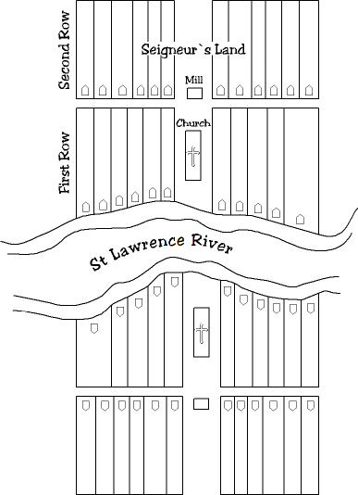
What did the King give the nobles (seigneurs)? He gave them large pieces of land along the St. Lawrence River.
Draw a sketch of the river and the land.

Why did the habitants want to be along the St. Lawrence River? Because there weren’t any roads and the river was used for transporting goods and materials and was used to irrigate the farmland.
The seigneur & habitant had duties to each other. What did each person have to do?
Seigneur: Find colonists to farm the land, build them a house, build a church and a grain mill.
Habitant: Had to give the Seigneur a portion of each years crop and pay other fees.
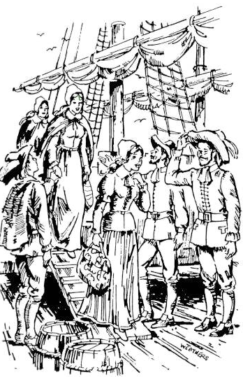
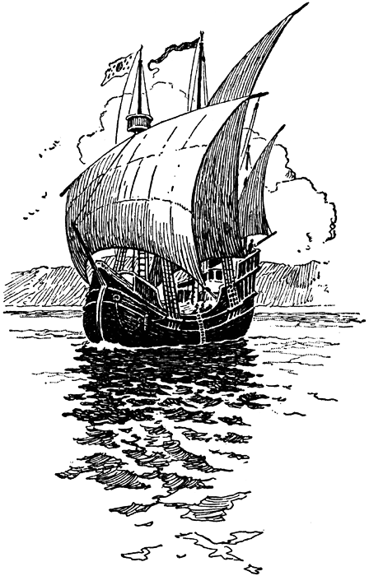
THROUGH HARD WORK AND PERSEVERANCE, THE CITIZENS OF NEW FRANCE LAID THE FOUNDATIONS OF CANADA.

