Chapter 2 - New France Puzzle Project Name:
There are many factors that contributed to the building of New France. This project will show how all those pieces fit together to make New France a successful colony.
Goal: Your assignment is to make a puzzle of New France that includes some of the main factors that contributed to the building of a new colony. This will be a 12 -piece puzzle that can include the following ideas:
- Jacques Cartier
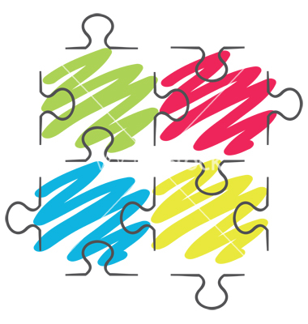
- Jesuit Missionaries
- Jean Talon
- First Nations
- King Louis XIV
- Imperialism of Europe (economics, competition, religion, curiosity)
- Samuel de Champlain
- Coureurs de Bois (adventure, freedom, $$$)
- Hudson Bay
- Furs and Fish
- Sovereign Council (governor, intendant, bishop)
- Catholic Church (priests, nuns, missionaries)
- Filles du Roi
- Seignerial System (seigneur, habitant)
- St. Lawrence River
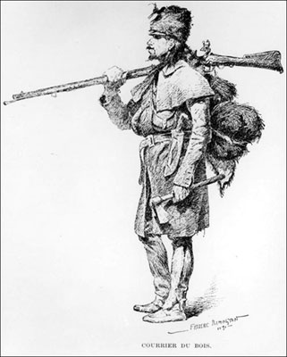
Make Sure: That one of the pieces has the following information on it: your name, class pattern, and a title for your puzzle.
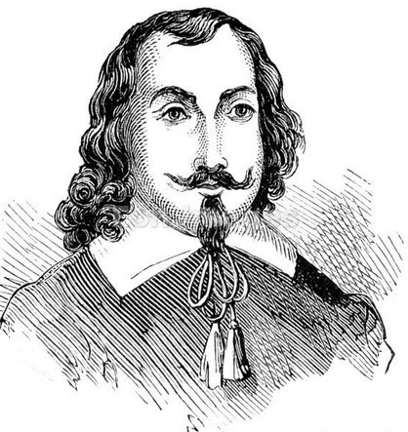
Front of Puzzle Piece - should have a contributing factor and symbol
Back of Puzzle - brief description explaining importance of contributing factor

Role - You are a puzzle maker. Your role is to make a puzzle designed for grade 7 students to help them review the beginning of New France.

You will be marked using the following rubric:
 | 25 - Excellent | 20 - Good | 10 - Limited | 5 - Insufficient
Shows an understanding of ideas, issues and information | Shows excellent understanding of ideas, issues and information | Shows considerable understanding of ideas, issues and information | Shows some understanding of ideas, issues and information | Shows limited understanding of ideas, issues and information
Visual literacy | Presents in a way that is persuasive and engaging and has a purpose that is consistently clear | Presents in a way that is mostly credible and interesting and has a purpose that is mostly clear | Presents in a way that is partly logical and has a purpose that is somewhat evident | Presents in a way that is confusing and/or does not show purpose
Total /50

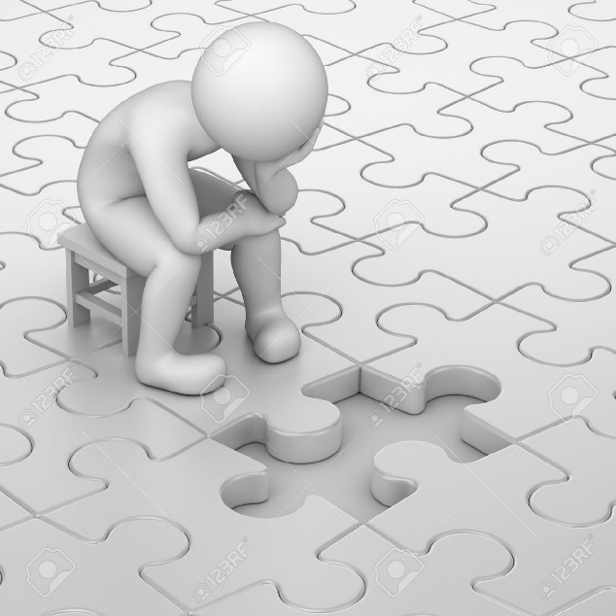
Performance: - You will be assessed according to how well you demonstrate an understanding of the factors that contributed to the building of New France. You need to pick out important factors and be able to highlight why it was so important.

Chapter Two Puzzle Project - Planning Sheet

Puzzle Piece Topic | Description – What was important about this topic and why are you using it? | Picture – What kind of picture could be used to describe this topic?
- The Name of your puzzle with your name and class pattern on it.

